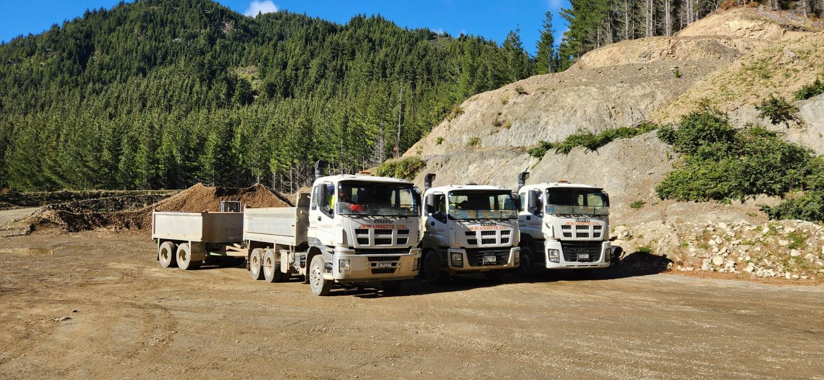
COOK QUARRY AT GWAVAS FOREST

